**Events Organized AT BCE Bhagalpur DURING JUNE’19- SEPT’19 UNDER TEQIP-III**

1. A Mason Skill Building Training workshop was organized on 29 July 2019 by Mr. Shounak Ray of **Ultratech Cement** on **“Good Practices and Quality assurance in civil engineering works”** for Contractors and Masons working in Bhagalpur. The faculty members and staffs of the department of civil engineering also participated in the workshop. The workshop consisted of PowerPoint presentation and lab visit where various Quality assurance experiment were conducted.

** **

**2. FDP by ECE Department (3-7 July 2019):** Electronics & Communication Engineering Department conducted an FDP on Digital Signal Processing.

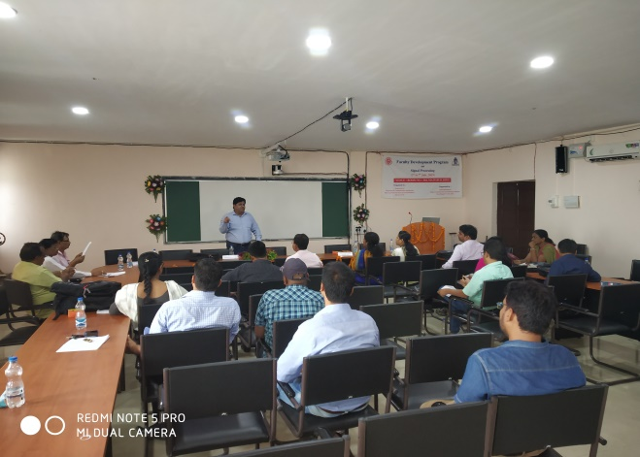 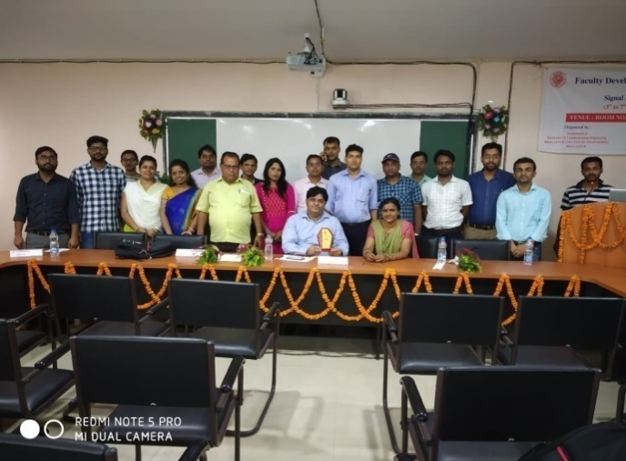

**The following topics were discussed in the FDP:**

● Provide recent trends and development in signal processing areas.

●Discuss state‐of‐the‐art developments and emerging techniques in Communication Engineering.

● Design and implementation of signal processing systems.

● Overview on Digital Signal Processing and its applications.

● Signal processing for smart learning and implementation.

● MultiMate signal processing and its importance over traditional signal processing.

● Bridge the gap between industry and academia

**3. FDP by Electrical Department (15-19 July 2019):** Electrical Engineering department conducted an FDP on Python Programming in collaboration with E&ICT Academy, IIT Guwahati.

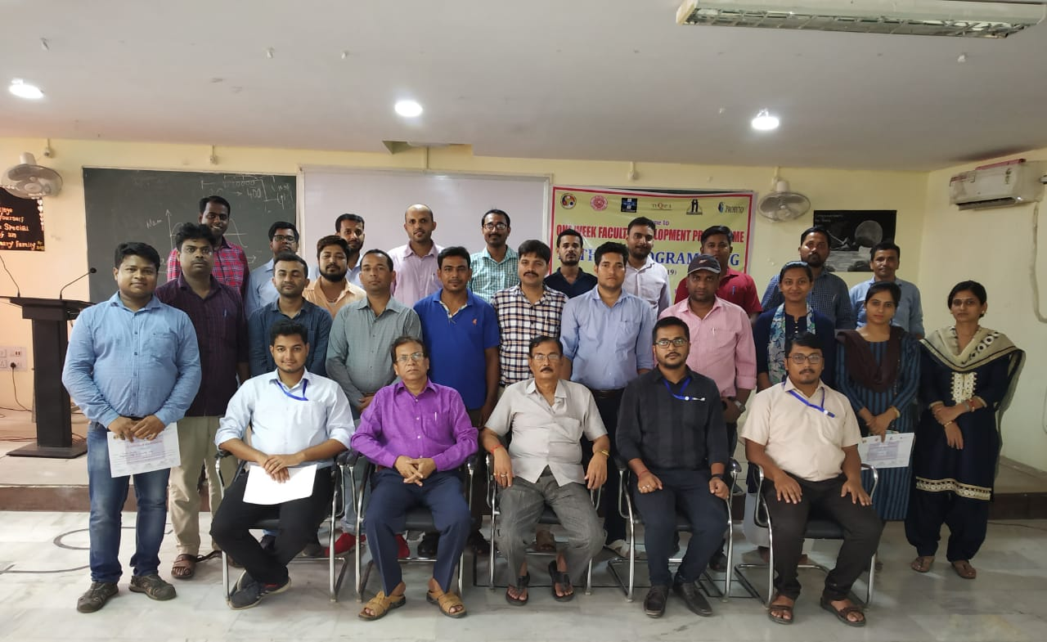

Speaking on the occasion, Prof. MK Jha (HoD, EE) said that it is great to host such an event at BCE Bhagalpur. The sessions were conducted by the experts from Probyto, Guwahati. The following topics were discussed during the FDP:

* Anaconda
* Jupyter notebook
* NumPy
* Pandas
* Matplotlib
* Basics of Python Programming including daily hands-on session

Overall the event was successful in achieving its target as to introduce the participants to the Python Programming in the simplest and most effective way.

**4. Plantation at BCE Bhagalpur on 09.08.2019:**

A plantation drive was conducted at BCE Bhagalpur with the aim of **‘One student, One Tree’**. All the students as well as faculty members participated in the event.

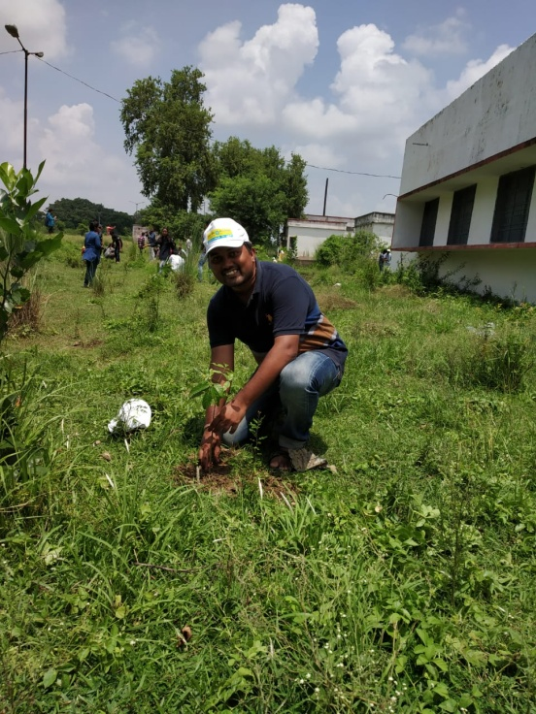 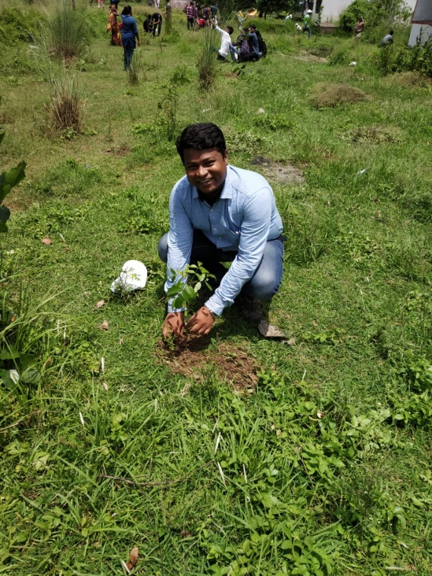

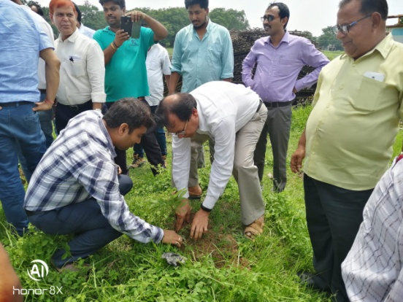 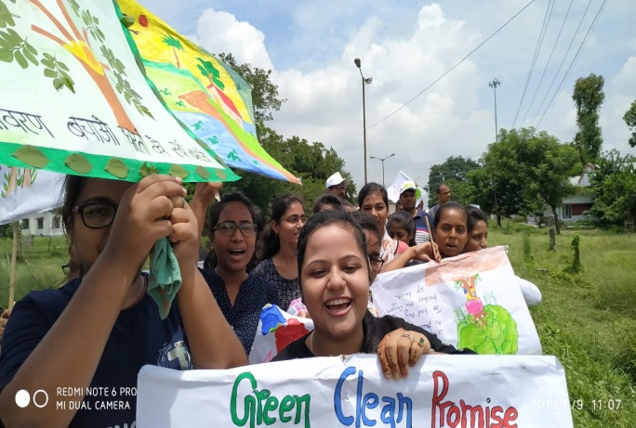

**5. Felicitation ceremony of NPTEL courses:** One of our students of civil engineering department Saurav Sharma was declared topper in NPTEL course on Plastic Waste Management. For this he received a trophy from NPTEL (IIT KGP):

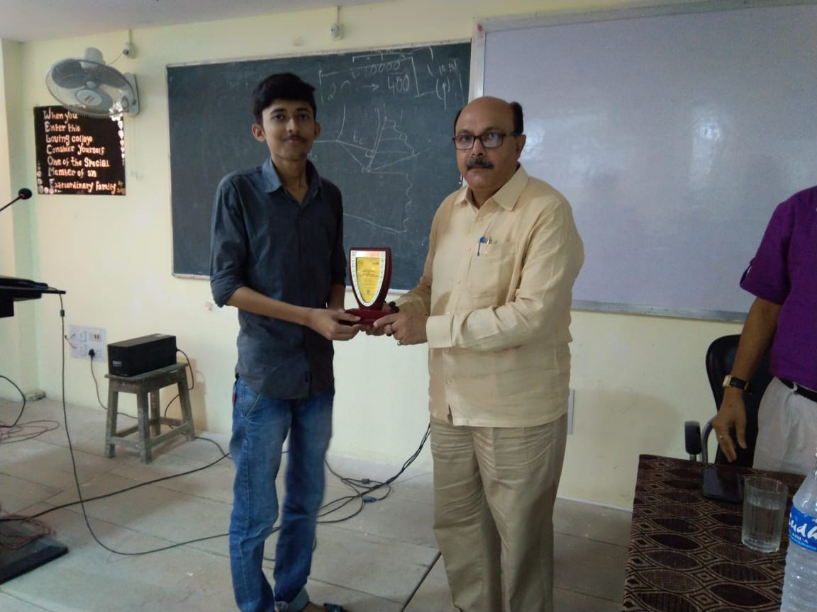

**6.** On 13.07.2019 to 15.07.2019,Sahil Gaurav, Rashmi Kumari and Rahul Kumar, students of Electrical Department, BCE Bhagalpur won the 1st prize in the project exhibition for the project **“Home Automation Bluetooth Control Device”** on **Viswa Yuwa Kaushal Diwas** at Gyan Bhawan, Patna.

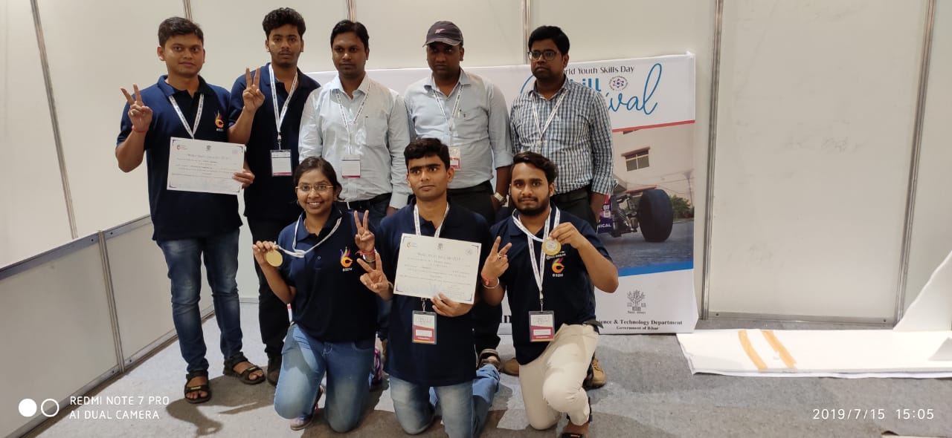 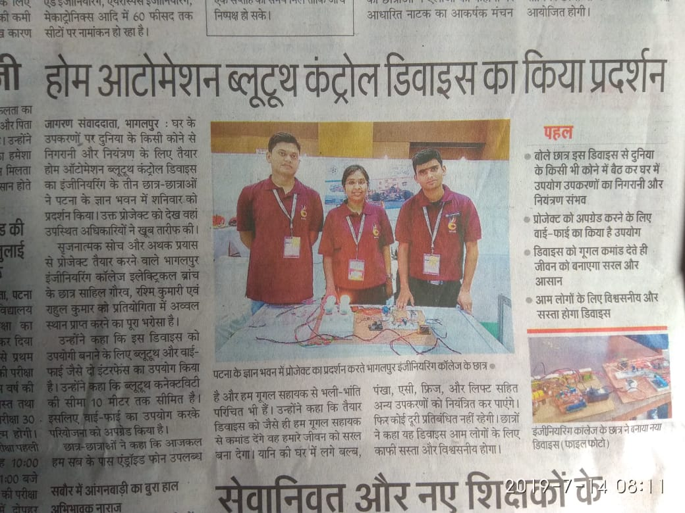

**7. A workshop on soft skills training for the students of second year was conducted from 29th July-3rd Aug,2019 in collaboration with Concord Consulting Services Pvt. Ltd. Bengaluru.**

The program mainly consisted of different small modules from speaking skills to personal hygiene. In these five days we did many group activities like public conversation, idea presentation, storytelling and Group discussion on social cause. One thing that I realized was it is not important to use complex words to sound sophisticated but to use simple words in pleasant way. The interview questioners were best part because it gave us opportunity to be in the moment of under pressure.

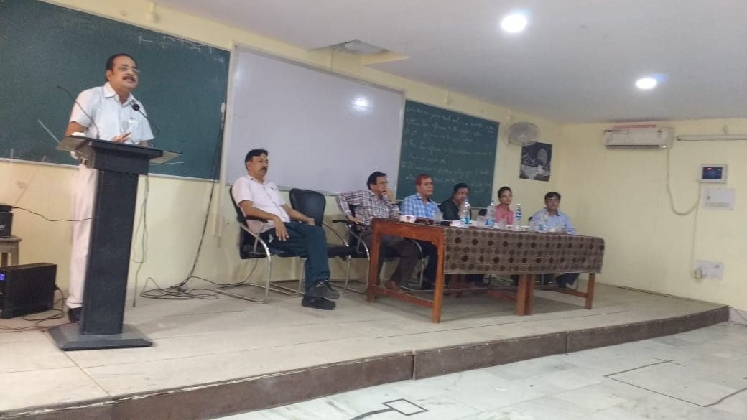 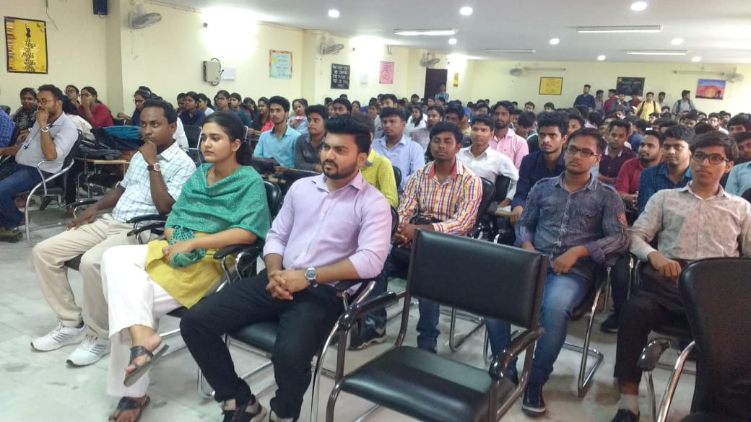

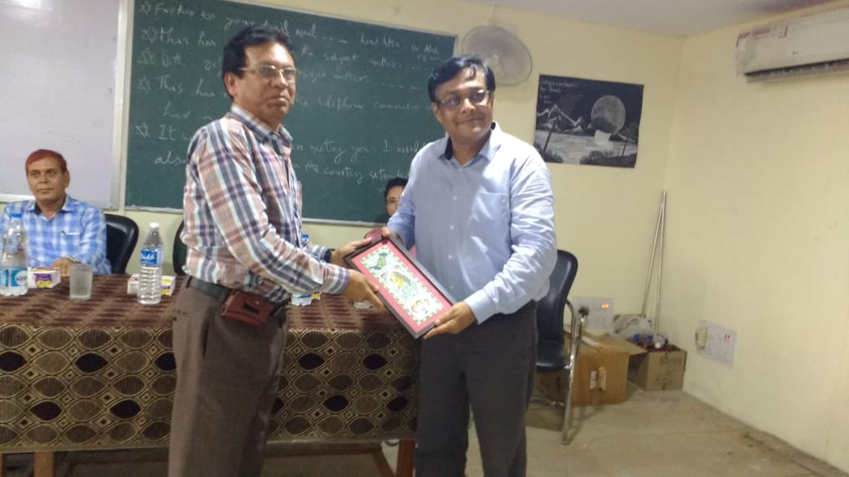 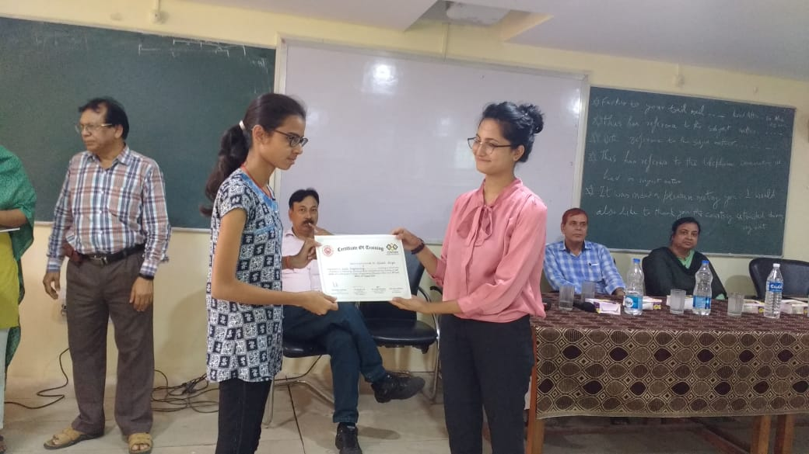

**8. A lecture series on Training & Placement and internship on 03.09.2019 by Dr. Arvind Dixit, Director & CEO, Advance Technology India Pvt. Ltd, Chandigarh**

For Pre-final and final year students a lecture series on Training & Placement and internship was organized on 03.09.2019. Session was addressed by Dr. Arvind Dixit, Director & CEO, Advance Technology India Pvt. Ltd, Chandigarh. This session helps the students to understand the latest trends in the industry and many other aspects of placement & internship.

