Events Organized AT BCE Bhagalpur DURING March’19- May’19 UNDER TEQIP-III

- Event: webinar on "Use of admixture in concrete"
The webinar of 60 minutes duration was conducted by UltraTech and hosted by BCE Bhagalpur on 28-03-2019.
Lecture was given by Dr. K.V.L. Subramaniam, Professor, Department of Civil Engineering.

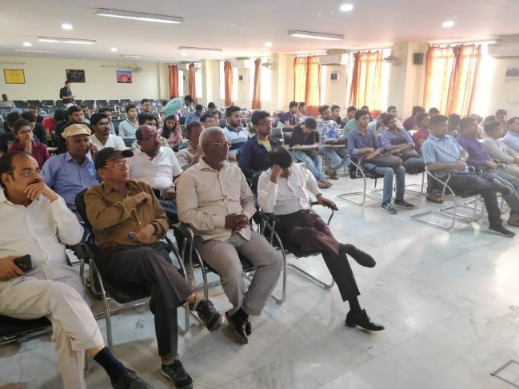
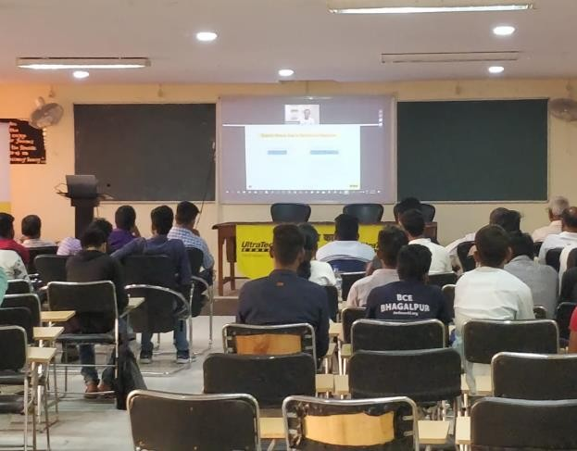

2. The event “SETUBANDH"
A bridge making competition was successfully held under "Civil Society”, Civil Engineering Department, BCE Bhagalpur on 10/04/2019. A total of 13 groups competed in the competition. The groups were given a total duration of 5.5 hours to design and build the bridge and submit it for testing. The evaluation was on the basis of efficiency and aesthetics of the bridge.
1st and 2nd prizes were bagged by BCE Bhagalpur while the 3rd prize was bagged by Government Polytechnic Bhagalpur.

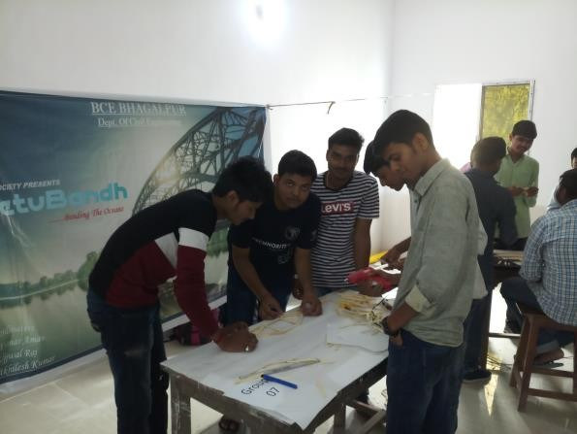
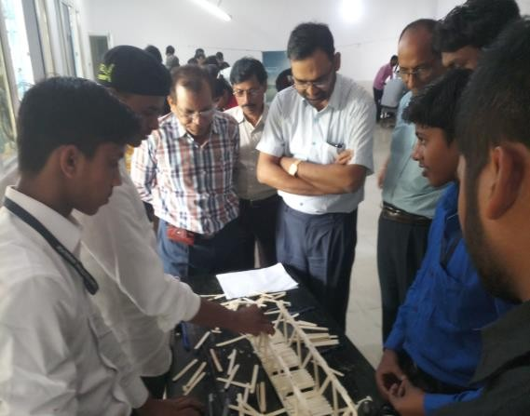
3. A workshop on IoT using Arduino:
Three days a hand on training was conducted for students and faculty members on “IoT using Arduino” in April’19. The event was organized by Electrical Engineering Department.
Photographs of the event
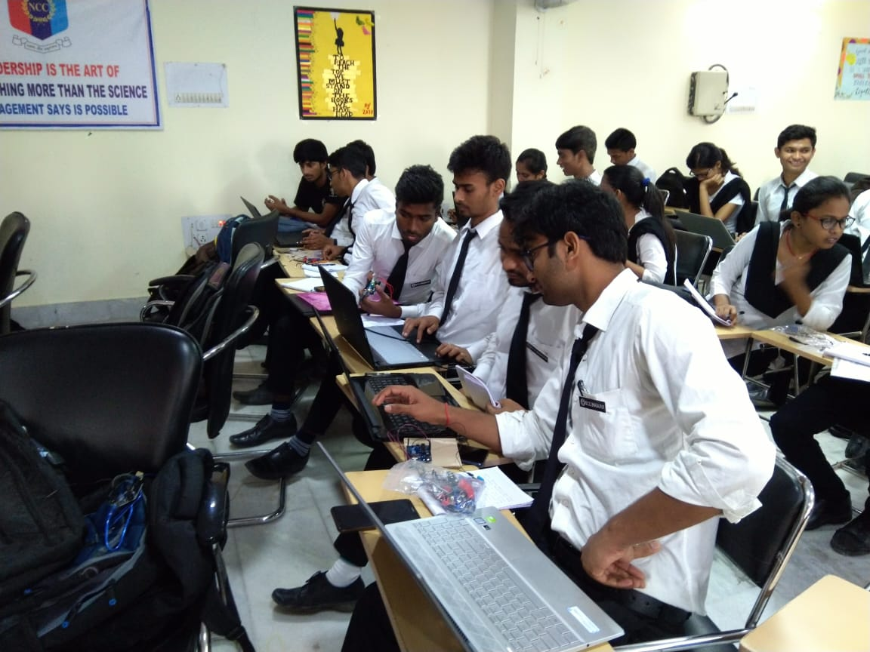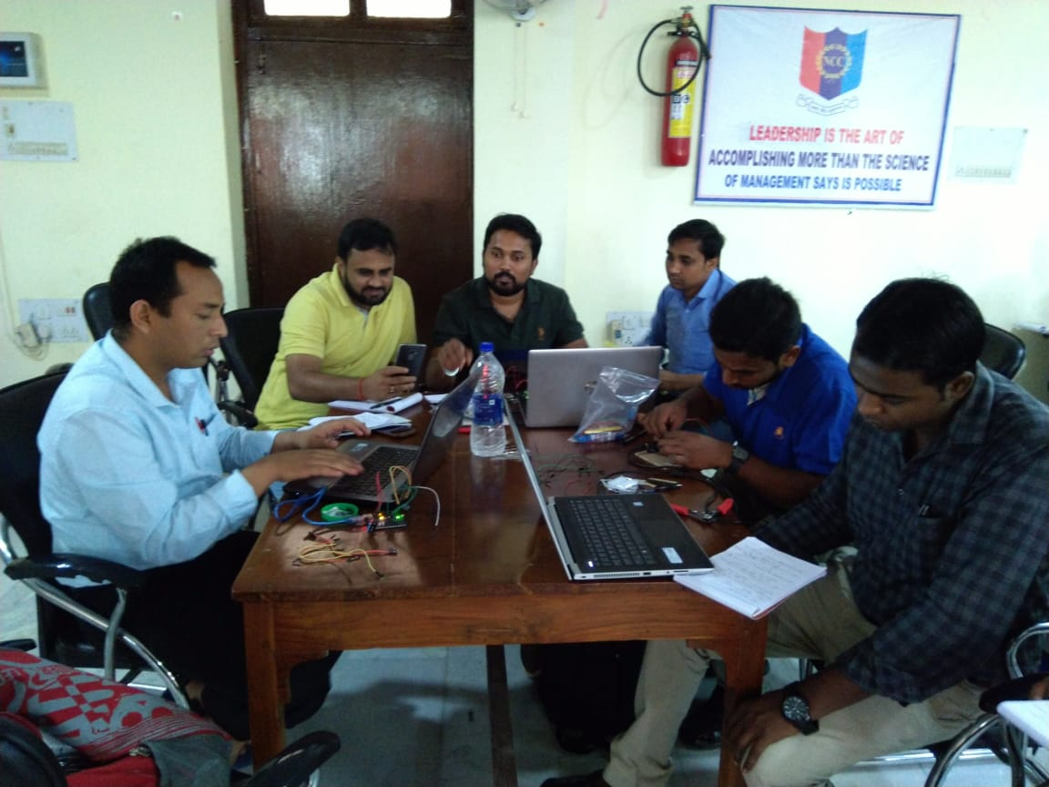
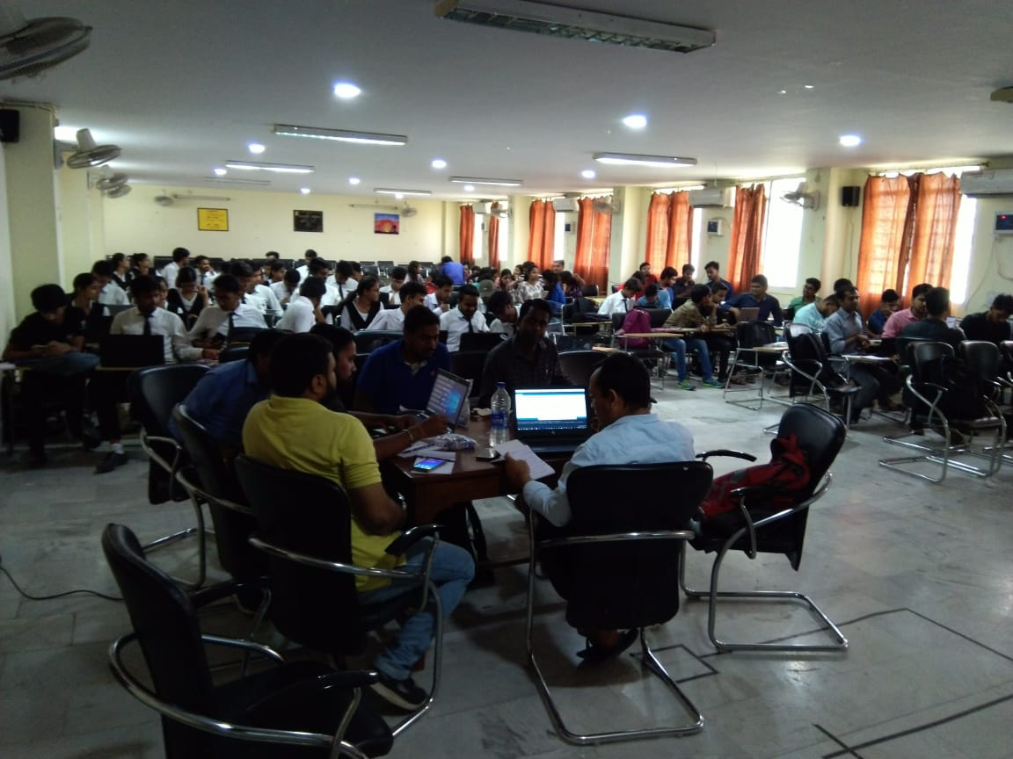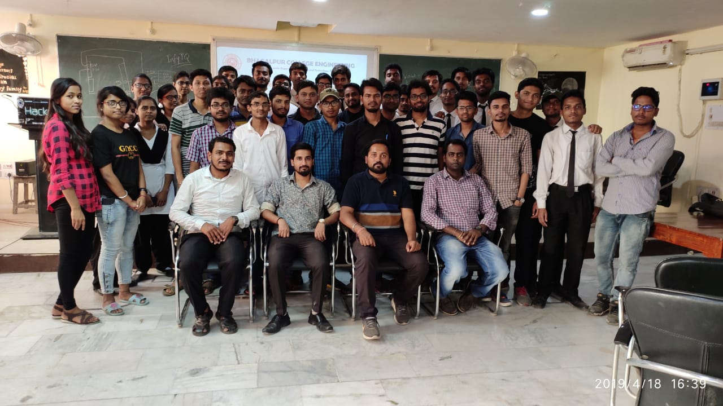

4. STUDENT EXCELLENCE & LEARNING PROGRAM
Art of Living’s Student Excellence & Learning Program (SELP) is a World Bank sponsored program which is exclusively designed for TEQIP-III institutes in collaboration with NPIU-MHRD in order to improve student learning.

OBJECTIVES
● Improvement in learning and research competency
● Increase student employability
● Create opportunities for youth to develop their socio-emotional and cognitive skills
● Enhance abilities of youth to handle stressful conditions
● Improve relationship between teachers and students
SCHEDULE
Day | Date | Timing | Module
1 | 22/04/2019 | 09:00 AM- 11:00 AM | Tendencies of mind and correlation with achieving success
2 | 23/04/2019 | 09:00 AM- 11:00 AM | EMI - Ethics, Morality and Integrity
3 | 24/04/2019 | 09:00 AM- 11:00 AM | Leadership and skillful communication
4 | 25/04/2019 | 09:00 AM- 11:00 AM | Introduction to yoga, meditation, deep breathing & relaxation and practical  de-stressing techniques
5 | 26/04/2019 | 09:00 AM- 11:00 AM | Confidence Building and handling peer pressure
6 | 27/04/2019 | 09:00 AM- 11:00 AM | Time management and goal setting

STUDENTS’ PARTICIPATION
Bhagalpur College of Engineering, Bhagalpur conducted the SELP with one (01) batch. The batch of 58 students included students mostly from first year and few 2nd year and 3rd year students. Around 20% participants were girls. The students who participated are enlisted below:
Student Name Roll. No.
- RAVI KUMAR GARG 16113
- RAJIV RANJAN 18245
- VIVEK KUMAR 18252
- HANSRAJ KUMAR 18244
- DURGESH KUMAR 18509
- KANCHAN KUMAR 18504
- KUNDAN KUMAR YADAV 16244
- GAURAV KUMAR 18309
- KESHAV RAJ 18311
- RITESH KUMAR 18411
- ABHINAV KUMAR 18207
- NISHANT KUMAR 18444
- SUMIT KUMAR SUMAN 18343
- HIMANSHU MISHRA 18458
- ANANT KUMAR 18466
- SUPRABHAT SHANTANU 18316
- PRIYANSHU KUMAR 18321
- NANDAN KUMAR SINGH 18102
- MOHIT GUPTA 18513
- RANVEER RAJ 18336
- MANISH KUMAR 18544
- DIVESH KUMAR 18512
- PIYUSH KUMAR SINHA 18341
- NIKKI KUMARI 18313
- ANITA KUMARI 18408
- ANJU KUMARI 18506
- PUMMY 18523
- VANDANA 18505
- SAKSHI GUPTA 18317
- SUSHMA KUMARI 18507
- SONALI KUMARI 18529
- NEHA KUMARI 18537
- SHUBHAM AKELA 18453
- VIJAY PRAKASH 18260
- DHIRAJ KUMAR 18254
- ABHIJEET KUMAR 18521
- SANTOSH KUMAR 18213
- SURAJ KUMAR 18501
- SARVESH KUMAR 18114
- VISHAL KUMAR 18531
- PRASHANT KUMAR 18533
- GAURAV KUMAR 18138
- MUKUND KUMAR 18434
- RAJESH KUMAR 18113
- ANAL RAJ 18524
- RAUSHAN KUMAR 18462
- ROHAN RAJ PATEL 18433
- SANJEET KUMAR 18238
- AVINASH KUMAR 18354
- ANURADHA KUMARI 18421
- AAROHI BHARTI 18107
- SUMIT KUMAR PASWAN 17128
- NISHANT NAMAN 17230
- SANJEET KUMAR 18238
- PRASHANT KUMAR YADAV 18141
- PIYUSH KUMAR 18222
- PRASHANT KUMAR 18443
- PRABHAS KUMAR 18449
INSTRUCTOR*
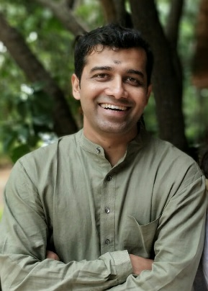
Mr. AkhileshParmanu is a member of faculty with the International Art of Living Foundation for the last 11 years and conducts training programs internationally, especially for young people. He conducts Art of Living's Happiness Program, Youth Empowerment & Skills (YES+) Workshop, I Excel I Lead (for corporations) & Volunteer Training Program (VTP). He has conducted workshops and sessions for approximately 15000 people which includes about 11000 youth.
He has conducted Art of Living workshops in India, Germany, Norway, Denmark, Finland, Belgium, South Africa, Thailand, Kenya, and Kazakhstan. He also led the Varanasi chapter of an international organization, SPIC MACAY (Society for the Promotion of Indian Classical Music And Culture Amongst Youth), and led his team to help support approximately 500 poor kids in Varanasi, including providing them proper school education.
CERTIFICATION
The students who attended the SELP modules were provided with certificates from The Art of Living, VyaktiVikas Kendra India.
PHOTOGRAPHS
From Top Left: Principal Prof. (Dr.) F. Ansari felicitating Mr. Akhilesh Parmanu; Principal Prof. (Dr.) F. Ansari, HoD, EE Dr. M. K. Jha, Former HoD, ME Prof. D. P. Kumar, Coordinator, TEQIP-III Prof. Anshul Shekhar and Mr. Akhilesh Parmanu awarding certificates to students in respective pictures.

5. Motivational Lecture by Dr. Ratna Mukherjee
On 24th May, 2019 at 11:30 AM in Auto Cad Lab a lecture on “Problem & Solution” was delivered by Prof.(Dr.) Ratna Mukherjee, Ex professor & Proctor (TilkaManjhi Bhagalpur University, Bhagalpur). She discussed how to control anger and how much important discipline is in our life. She shared several stories that will guide us to behave properly in our day today life.
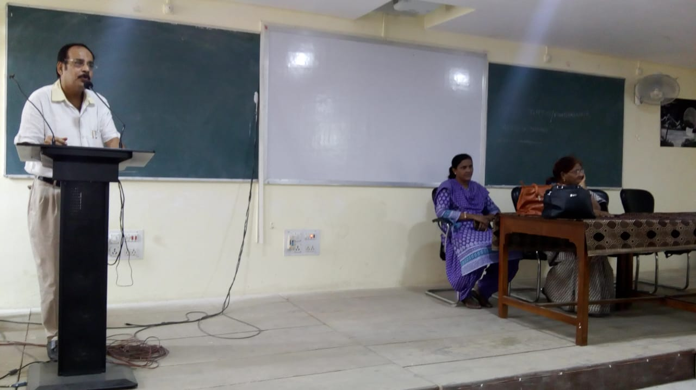

6. Faculty Development Programme on “Future Aspects of Renewable Energy Innovation”(17th - 21st May, 2019)

Inauguration Programme
(10.30 am to 11.30 am, 17th May 2019)
10.30 am - 10.40 am Lighting of the Lamp

10.40 am - 10.50 am Welcome by Dr. Manish Kumar, Convener

10.50 am – 11.00 am Address by Prof. (Dr.) F. Ansari, Principal, BCE Bhagalpur

11.00 am – 11.10 am Prof. Arvind Choubey, Director, IIIT Bhagalpur

11.10 am – 11.20 am Dr. Arnab Sarkar, Chief Guest, IIT (BHU) Varanasi

11.20 am National Anthem
Session Schedule
Session | I |  |  | Lunch | II
Lecture | 10:30-11:30 | Tea Break | 12:00-1:00 |  | 2:30-3:30 | Tea Break | 4:00-5:00
Day 1 | Inaugral |  | Introduction of Renewable Energy  (Dr. A. Sarkar) |  | Wind Climate Modelling  (Dr. A. Sarkar) |  | Wind Climate Modelling  (Dr. A. Sarkar)
Day 2 | Waste to energy  (Prof. D. Mohan) |  | Waste to energy  (Prof. D. Mohan) |  | Solar Thermal Energy and It’s Applications  (Prof. A. Layek) |  | Solar Thermal Energy and It’s Applications  (Prof. A. Layek)
Day3 | Artificial Roughness-A Potential Method for Efficiency Enhancement of Solar Air Heater  (Prof. A. Layek) |  | Artificial Roughness-A Potential Method for Efficiency Enhancement of Solar Air Heater  (Prof. A. Layek) |  | Developing a Zero waste industrial complex  (Prof. D. Mohan) |  | Developing a Zero waste industrial complex  (Prof. D. Mohan)
Day4 | Energizing the waste: Biomass Based Gasifier Heating System for Energy and Environment Applications  (Dr. R. Raj) |  | Energizing the waste: Biomass Based Gasifier Heating System for Energy and Environment Applications  (Dr. R. Raj) |  | Efficient Boiling for Improved Energy Efficiency in Earth and Reduced Gravity Heat Transfer Applications  (Dr. R. Raj) |  | Efficient Boiling for Improved Energy Efficiency in Earth and Reduced Gravity Heat Transfer Applications  (Dr. R. Raj)
Day 5 | Porous Materials, Renewable Sources & Energy  (Dr. P. Kalita) |  | Porous Materials, Renewable Sources & Energy  (Dr. P. Kalita) |  | Valedictory
Speakers:
Dr. A. Sarkar- IIT (BHU), Varanasi
Prof. D. Mohan- IIT (BHU), Varanasi
Prof. A Layek- NIT, Durgapur
Dr. Rishi Raj- IIT, Patna
Dr. Pranjal Kalita- CIT, Kokrajhar

Media Coverage
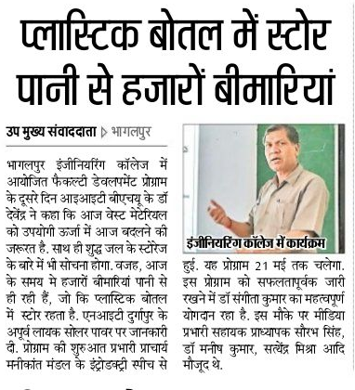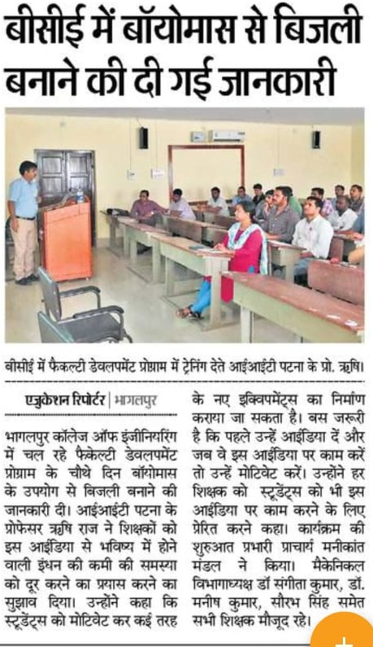

Photographs of FDP
